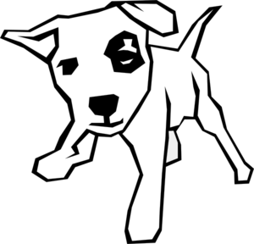
I am giving you this dog.
His name is Spot.
I thought you might want him, as you seem to be trying to take as many spots as possible. I hope this helps.

