Many three year olds have trouble staying within the lines.
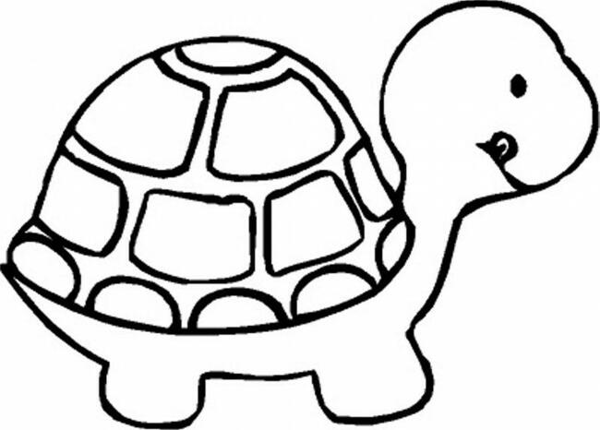
Maybe if you practice coloring this turtle, it will help with your parking.

